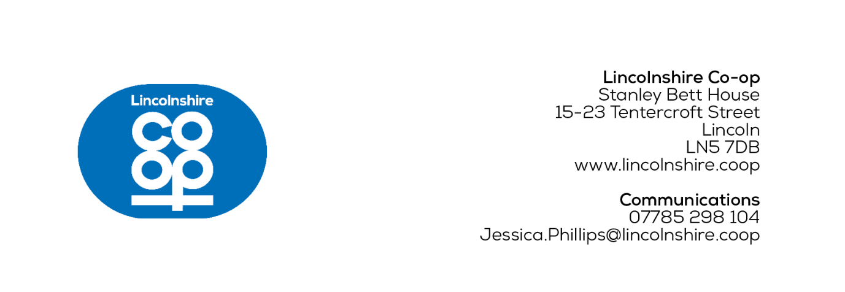
MEDIA RELEASE
[20/11/2025]
Retailer upgrades shelf edge labels with £4m investment
Electronic Shelf Edge Labels (ESELs) are being rolled out across all 100 Lincolnshire
Co-op food stores, as part of a £4m food technology transformation.
Approximately, food store colleagues manually change 550 labels a week which can rise to 2,000 during an ambient promotion changeover week.
Moving to a digital system removes the need for colleagues to print and replace labels manually, meaning hours of their time will be saved to help shoppers and colleagues can also react faster to pricing changes.
The electronic labels will also save over £100,000 on paper, toner and printing per year, contributing to Lincolnshire Co-op's sustainability strategy.
This investment is also part of the co-operative's Purpose Beyond Profit 2030 business strategy, designed to build strength in the long term.
The electronic labels were first trialled in Lincolnshire Co-op's The Bridge Food Store in Newark during October 2025 and the colleagues are delighted with the transformation.
Jane Wheeler, The Bridge Food Store Manager, said: “I can’t speak highly enough of the new electronic labels – they’re easy to use and incredibly reliable.
“It’s a massive but positive change to how the team continues to deliver exceptional customer service and, when new promotions arrive, we’re confident our store will be ready to trade.”
Customers will also see benefits from the upgraded labels. Pricing, offers and promotional deals will be clearer to read, and product information will be more accessible.
The rollout will be completed by the end of 2025 and all the society’s future food stores plan to open with the new technology.
Paul Fitzpatrick, IS Solution Delivery Manager, said: “This is an exciting time for the business to bring a future-ready platform to our food stores, to help us drive operational excellence and build strength in the long term.
“We want to provide a foundation in which technology is the enabler to remove administrative related tasks so time can be released for colleagues to focus on the customer. These Electronic Shelf Edge Labels will help us do that.”
Leading shelf edge label company and project partner SOLUM provided the in-store equipment and co-ordinated installation teams to deliver the store deployment.
Mark Duckworth, Country Manager at SOLUM UK & Ireland, said: “Our partnership with Lincolnshire Co-op reflects a shared commitment to putting customers first and driving meaningful retail innovation.
“At SOLUM, we’re dedicated to delivering high-quality products and smart retail solutions that support our customer’s digital transformation and contribute to the ongoing advancement of the UK retail sector.”
Ends
For more information contact:
Jess Phillips, Communications Co-ordinator
07785 298 104
Jessica.Phillips@lincolnshire.coop
CONTACT DETAILS NOT FOR PUBLICATION

Notes to editors:

- Lincolnshire Co-op is an independent co-operative society. Its purpose is to bring together ideas, energy and resources to make life better in communities. It has around 300,000 members and 2,900 local colleagues in Lincolnshire and the surrounding counties and an elected board of directors who oversee the business. The society provides valued services and supports the local economy from outlets across its trading area including food stores, filling stations, post offices, travel branches, funeral homes, a florist, a crematorium and community libraries. It also cares for people’s health and wellbeing through its pharmacies and support for a network of wellbeing walks. Local good causes benefit through its Community Champions scheme and together, colleagues and members also look after the local environment through volunteering.
As well as its trading outlets, Lincolnshire Co-op owns properties, from flats and houses to commercial premises. The society brings land and buildings back into use to create attractive environments. With Lincolnshire Co-op as landlord, rents stay local and are invested in schemes that benefit the community.

