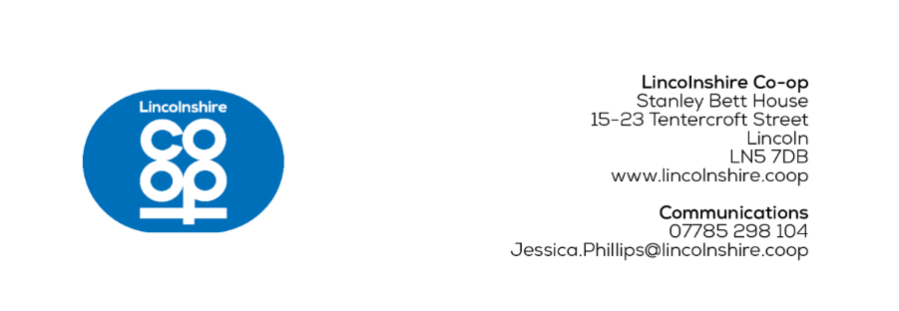
MEDIA RELEASE
[26/05/2026]

Food retailer launches Holland & Barrett range
Lincolnshire Co-op has partnered with Holland & Barrett by introducing a range into 28 food stores, to strengthen health and wellbeing across Lincolnshire and the surrounding area.
One colleague in each selected store has been trained as a Holland & Barrett Champion, who will be on hand to help customers and answer their questions.
Sarah Hagues, Team Leader from Lincolnshire Co-op's Riseholme Road Food Store in Lincoln, said: “I was excited to become a Holland & Barrett Champion because I know how important these products are for our health; I take vitamins myself.
“The training day was really valuable, it was interesting to learn about different wellbeing products, and I’m looking forward to using my knowledge to help my customers.”
This new range will improve local access to wellbeing services and ensure customers feel supported with their healthy habits.
Customers will be able to purchase a variety of wellness products including omega fish oil, collagen tablets and multivitamins for youngsters.
Liam Uzzell, Buying Manager at Lincolnshire Co-op, said: “We recognise the health landscape is changing and customers are seeking more proactive ways to manage their health, and we’re committed to helping them do this.
“Our partnership with Holland & Barrett demonstrates how we’re supporting healthier communities, by bringing a credible and high-quality range of wellness solutions directly into our stores.”
Guy Farmer, Chief Commercial Officer at Holland & Barrett, said: “We’re delighted to partner with Lincolnshire Co-op to help people live healthier lives across the region.
“By bringing our expertise into more convenient locations, we can help support even more customers on their individual health and wellness journeys with trusted, quality products and knowledgeable colleagues in store.”
The range can be found at Birchwood in Lincoln, Brant Road in Lincoln, Carlton in Selby, Collingham, Crowland in Peterborough, Dunholme in Lincoln, Eastwood Road in Boston, Haxey, Hykeham Green, Holbeach, Lincoln Road in Sleaford, Long Bennington, Morton Bourne, Misterton in Doncaster, Navenby, Nettleham, Newark Road Hykeham, Riseholme Road in Lincoln, Scartho, Scawby, Scotter, Skellingthorpe in Lincoln, Waltham in Grimsby, Warsop, Welton, Whittlesey, Witham St. Hughes and Wybers Wood in Grimsby.
Ends
For more information contact:
Jess Phillips, Communications Co-ordinator
07785 298 104
Jessica.Phillips@lincolnshire.coop
CONTACT DETAILS NOT FOR PUBLICATION

Notes to editors:
- Lincolnshire Co-op is an independent co-operative society. Its purpose is to bring together ideas, energy and resources to make life better in communities. It has around 300,000 members and 2,900 local colleagues in Lincolnshire and the surrounding counties and an elected board of directors who oversee the business.
The society provides valued services and supports the local economy from outlets across its trading area including food stores, filling stations, post offices, travel branches, funeral homes, a florist, a crematorium and community libraries. It also cares for people’s health and wellbeing through its pharmacies and support for a network of wellbeing walks. Local good causes benefit through its Community Champions scheme and together, colleagues and members also look after the local environment through volunteering.
As well as its trading outlets, Lincolnshire Co-op owns properties, from flats and houses to commercial premises. The society brings land and buildings back into use to create attractive environments. With Lincolnshire Co-op as landlord, rents stay local and are invested in schemes that benefit the community.

