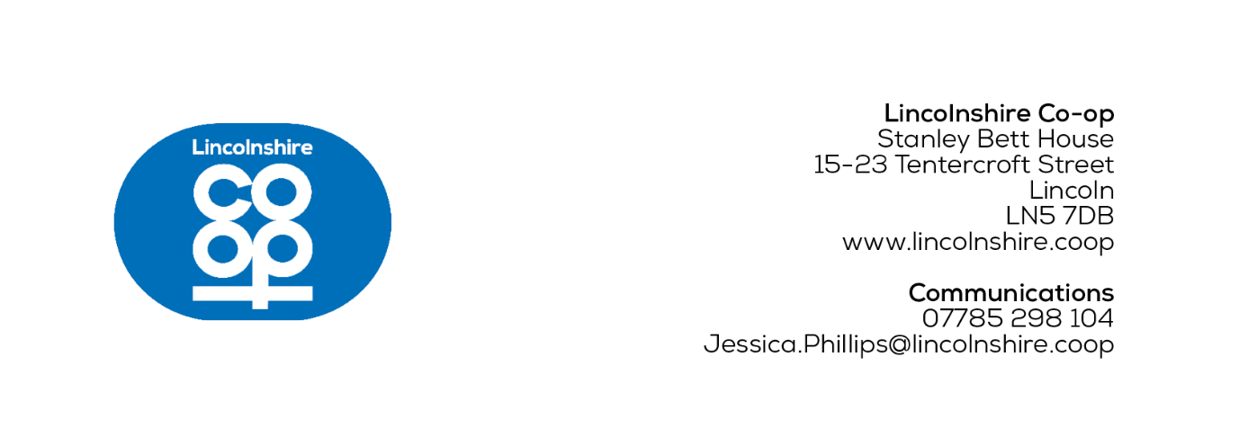
MEDIA RELEASE
[26/09/2025]
New funeral home opening doors to Horncastle community
The Horncastle community are invited to tour a new £1.2m Lincolnshire Co-op funeral home during an open day on Saturday 18th October between 11am and 2pm.
This is a unique opportunity to look at what’s inside a funeral home, and Funeral Home Director Carla Kennedy commented that it’s part of an effort to encourage more conversations and break down barriers surrounding funerals and what services are available for families.
Carla said: “Our team know walking into a funeral home can feel intimidating or unfamiliar, so we want this open day to be an event where the community can learn more about what we provide.
“By opening our doors, we hope to deepen our connection with the local community and offer reassurance by showing local people we’re here to support them.
At the open day, members of the public can expect light refreshments upon arrival, a children’s colouring activity, and a horse and carriage on display provided by local partner D K Carriage Horses, based in Grantham.
The new funeral home is at the former Travis Perkins building merchants site on Bridge Street and will open to the public on Monday 20th October at 9am, with the team relocating from the existing funeral home in the Market Place.
There will be an invitation only dedication service on Thursday 16th October, which will include a chapel blessing and speeches.
Lincolnshire Co-op is currently seeing major refurbishments take place under its cyclical refresh programme, which will see work happen at around 40 of its outlets annually, with an estimated yearly investment of £5 million.
Plans for the new funeral home outline a modern look, incorporating wooden textures and a natural colour palette of purple and green, lending itself to create a warm, homely and calming space for clients.
There will be a range of pastoral care services including a dedicate arrangement office, a chapel of rest and private reflection spaces for families.
While this is a new funeral home for Lincolnshire Co-op and the Horncastle community, this is a fresh look that will also shape the society’s future funeral branch refits and brand-new funeral homes.
Lincolnshire Co-op Funeral Service Manager, Sash Mirhadi, said: “It’s been fantastic to see the transformation of our new funeral home taking shape and we’re excited to give a new lease of life to a historic building.
“We’re creating a space where the Horncastle team can continue their exceptional work to care for even more families and it will be great to welcome the local residents on opening day.”

Ends
For more information contact:
Jess Phillips, Communications Co-ordinator
07785 298 104
Jessica.Phillips@lincolnshire.coop
CONTACT DETAILS NOT FOR PUBLICATION

Notes to editors:

- Lincolnshire Co-op is an independent co-operative society. Its purpose is to bring together ideas, energy and resources to make life better in communities. It has around 300,000 members and 2,900 local colleagues in Lincolnshire and the surrounding counties and an elected board of directors who oversee the business.
The society provides valued services and supports the local economy from outlets across its trading area including food stores, filling stations, post offices, travel branches, funeral homes, a florist, a crematorium and community libraries. It also cares for people’s health and wellbeing through its pharmacies and support for a network of wellbeing walks. Local good causes benefit through its Community Champions scheme and together, colleagues and members also look after the local environment through volunteering.
As well as its trading outlets, Lincolnshire Co-op owns properties, from flats and houses to commercial premises. The society brings land and buildings back into use to create attractive environments. With Lincolnshire Co-op as landlord, rents stay local and are invested in schemes that benefit the community.

