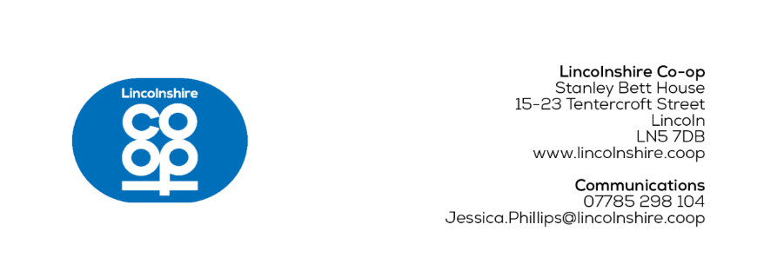
MEDIA RELEASE
[16/10/2025]
Guests invited to tour new Horncastle funeral home

Local dignitaries were invited for an exclusive first look at a new £1.2m funeral home during a VIP dedication service.
The event took place at the new Lincolnshire Co-op Horncastle Funeral Home on Thursday 16th October, and the funeral home will open on Monday 20th October at 9am.
On the day, attendees were guided on a tour of the building by the funeral colleagues. Jane Moate, Lincolnshire Co-op Director and Society President gave a speech and Reverend Canon Charles Patrick, from St. Mary’s Church in Horncastle, led the chapel blessing.
One guest was local Horncastle resident Priscilla Burbidge whose parents, Christopher and Alice, rented the building in the 1940s as a draper's shop. Inside they sold women’s and men’s clothing, fabrics, baby prams, children’s toys and more.
Priscilla said: “Walking around the funeral home has been quite emotional and brought back many lovely memories from when I was a little girl, like watching the dressmakers sew and looking at the fish in the river nearby.
“I’m completely blown away by the building and learning about how it’s been updated to provide an exceptional service for the community, it’s been surreal to see the transformation of such a historic building.”
A community open day is also being held on Saturday 18th October between 10am and 2pm to encourage conversations surrounding funerals and showcase the funeral home’s facilities.
The £1.2m funeral home can be found at the former Travis Perkins building merchants site on Bridge Street, with the team relocating from the existing funeral home at Market Place.
Inside, there’s an improved layout and a range of pastoral care services including a dedicated arrangement office, a chapel of rest and private reflection spaces for families.
It will be more accessible for visitors, being all on one level, with seven dedicated client car parking spaces.
The new facility’s design, developed by Framework Architects, honours the building’s heritage with a reinstated frontage. The building’s main entrance, facing onto Bridge Street, has be restored, and the existing glazing has been replaced with a large Georgian-style window.
The conversion programme included work to the roof, restoration of all windows and significant work to the building’s interior. It was undertaken by contractors TopCon Building, based in Grimsby.
Lincolnshire Co-op is currently seeing major refurbishments take place under its cyclical refresh programme, which will see work happen at around 40 of its outlets annually, with an estimated yearly investment of £5 million.
Opening with a fresh and modern look, the outlet incorporates wooden textures and a natural colour palette of purple and green, creating a warm and calming space for clients.
This is a new funeral home for the society and the Horncastle community but it’s also a fresh look that will shape Lincolnshire Co-op’s future funeral branch refits and brand-new funeral homes.
When members use their dividend card in all Lincolnshire Co-op outlets, donations are made to the society’s Community Champions scheme which helps hundreds of local charities each year. Banovallum Brass Training Band and First Horncastle Guides are currently benefitting from funding raised in Lincolnshire Co-op’s Horncastle outlets.
Funeral colleagues have also undertaken community outreach by helping at the Horncastle Community Larder during Horncastle’s Harvest Horse Festival, receiving over 1,500 donations and inviting local people to the open day.
Lincolnshire Co-op’s Horncastle Funeral Home Director, Carla Kennedy, said: “We’re thrilled to be opening the doors to our new funeral home to the community. It’s been wonderful to welcome our visitors inside so they can see the quality of our facilities and the care we provide.
“It’s a great privilege to continue supporting local families and the team takes great pride in being here for our clients when they need us most.”
Ends
For more information contact:
Jess Phillips, Communications Co-ordinator
07785 298 104
Jessica.Phillips@lincolnshire.coop
CONTACT DETAILS NOT FOR PUBLICATION
Notes to editors:

- Lincolnshire Co-op is an independent co-operative society. Its purpose is to bring together ideas, energy and resources to make life better in communities. It has around 300,000 members and 2,900 local colleagues in Lincolnshire and the surrounding counties and an elected board of directors who oversee the business.
The society provides valued services and supports the local economy from outlets across its trading area including food stores, filling stations, post offices, travel branches, funeral homes, a florist, a crematorium and community libraries. It also cares for people’s health and wellbeing through its pharmacies and support for a network of wellbeing walks. Local good causes benefit through its Community Champions scheme and together, colleagues and members also look after the local environment through volunteering.
As well as its trading outlets, Lincolnshire Co-op owns properties, from flats and houses to commercial premises. The society brings land and buildings back into use to create attractive environments. With Lincolnshire Co-op as landlord, rents stay local and are invested in schemes that benefit the community.

